Ideation Phase
Brainstorm & Idea Prioritization Template

Date | 01 October 2026
Team ID | SWTID-2026-7653
Project Name | Script-Controlled ACL – Restrict Record Access Based on Field Value
Maximum Marks | 4 Marks

Brainstorm & Idea Prioritization Template:
Brainstorming provides a free and open environment that encourages everyone within a team to participate in the creative thinking process that leads to problem solving. Prioritizing volume over value, out-of-the-box ideas are welcome and built upon, and all participants are encouraged to collaborate, helping each other develop a rich amount of creative solutions.
Use this template in your own brainstorming sessions so your team can unleash their imagination and start shaping concepts even if you're not sitting in the same room.
Reference: https://www.mural.co/templates/brainstorm-and-idea-prioritization

Step 1: Team Gathering, Collaboration and Select the Problem Statement
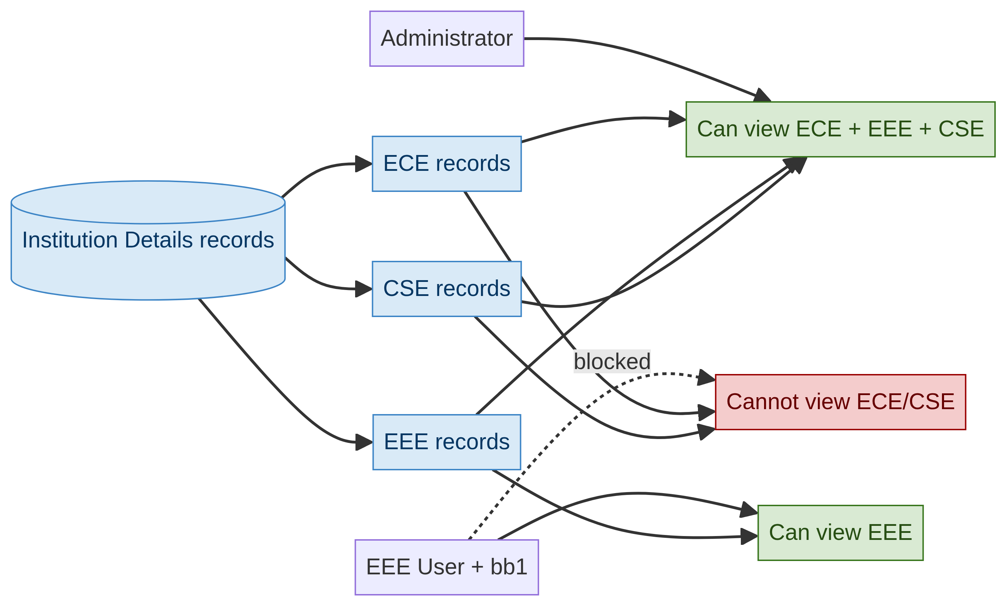
Project visual: branch-based record visibility in u_institution_details.
Selected problem: ServiceNow must restrict access to institution records according to the user role and the Branch field value, while allowing administrators full access and supporting separate permissions for read, create, write and delete.

Step 2: Brainstorm, Idea Listing and Grouping
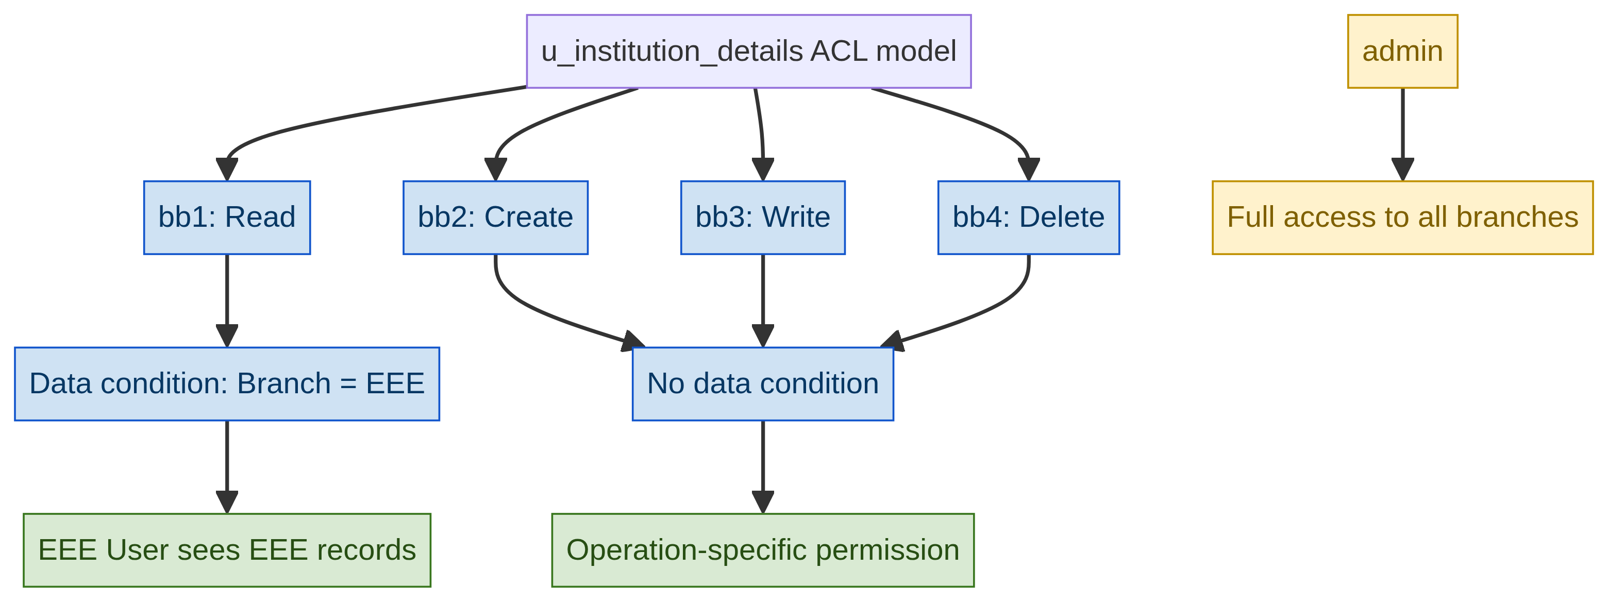
Project visual: role-to-operation mapping for the ACL model.
Group | Ideas
Data setup | Create u_institution_details; add Student Roll Number, Student Name, Faculty Name, Branch, Email, Phone Number and Description; create ECE, EEE and CSE records.
Access design | Create a scripted read ACL; use bb1 with the EEE data condition; retain an admin bypass.
Operation control | Create separate ACLs for create (bb2), write (bb3) and delete (bb4).
Verification | Impersonate EEE User and Admin; verify list access, record visibility and permitted actions.

Step 3: Idea Prioritization
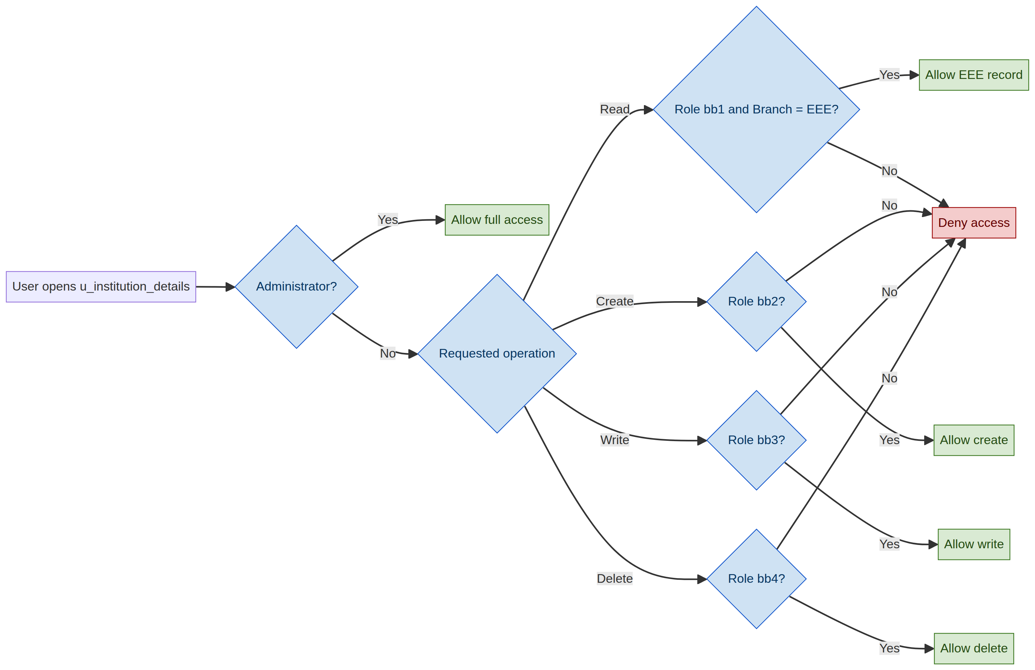
Project visual: script-controlled ACL decision flow.
Priority | Idea | Reason
1 | Read ACL with bb1, EEE condition and admin bypass | Core requirement: proves record-level visibility control.
2 | Create representative ECE, EEE and CSE records | Makes the Branch condition testable.
3 | Separate create, write and delete ACLs | Matches the project milestone and avoids broad permissions.
4 | Impersonation-based verification | Shows the actual behavior for different user contexts.
5 | Document test results | Makes the lab repeatable and easier to evaluate.

Selected concept
Use role- and field-aware ACLs on u_institution_details. Administrators receive full access; bb1 controls EEE record visibility; bb2, bb3 and bb4 progressively control create, write and delete. This directly matches the supplied project document.
Visual note: The diagrams in this completed template are generated specifically from the project roles, ACL operations and Branch condition; the generic brainstorming visuals from the original template have been removed.

